  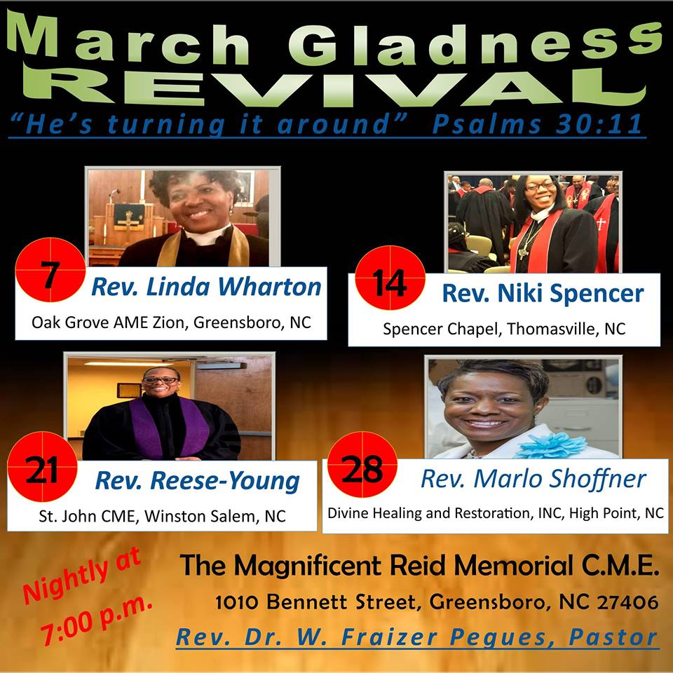
  March | 2018
  Sunday School
  Sunday Mornings at 8:30a.m.
  Sunday Morning Worship Service
  Sundays at 10a.m.
  Hour of Power Bible Study
  Wednesdays at 12 noon
  Wednesdays at 7p.m.
  Live Bible Study via Conference Call: (605)472-5814 Access Code: 776746
  Hour of Power Play Back:
  (605)472-5902# + reference number
  Boards and Auxiliaries
  - Missionary Society is collecting back packs to be donated to Foster Care Organization of Greensboro, NC
  - The Dudley Project please see Sis. Brenda Barksdale

Sunday | Monday | Tuesday | Wednesday | Thursday | Friday | Saturday
 |  |  |  | 1 | 2 | 3
 |  |  | Hour of Power noon day bible study will continue as scheduled for the month of March |  |  | Morning Glory Prayer 6:00a.m.
4 | 5 | 6 | 7 | 8 | 9 | 10
 |  |  | March Gladness Revival 7:00p.m. Rev. Linda Wharton of Oak Grove AME Zion Greensboro, NC |  |  | Men’s Day Kick Off Fellowship Breakfast 8a.m. to 10p.m.
11 | 12 | 13 | 14 | 15 | 16 | 17
The Steward Board will host a program at 2:30p.m. The Young Adult Reunion Choir in Concert |  |  | March Gladness Revival 7:00p.m. Rev. Niki Spencer of Spencer Chapel CME Thomasville, NC |  |  | MWB  Men with Brooms Ministry (Sweeping Up the City) 3:00p.m.
18 | 19 | 20 | 21 | 22 | 23 | 24
 |  |  | March Gladness Revival 7:00p.m. Rev. Regina Reese-Young of St. John CME WS NC
25 | 26 | 27 | 28 | 29 | 30 | 31
 | Church Conference  6:30p.m. |  | March Gladness Revival 7:00p.m. Rev. Marlo Shoffner of DHRM High Point, NC

